

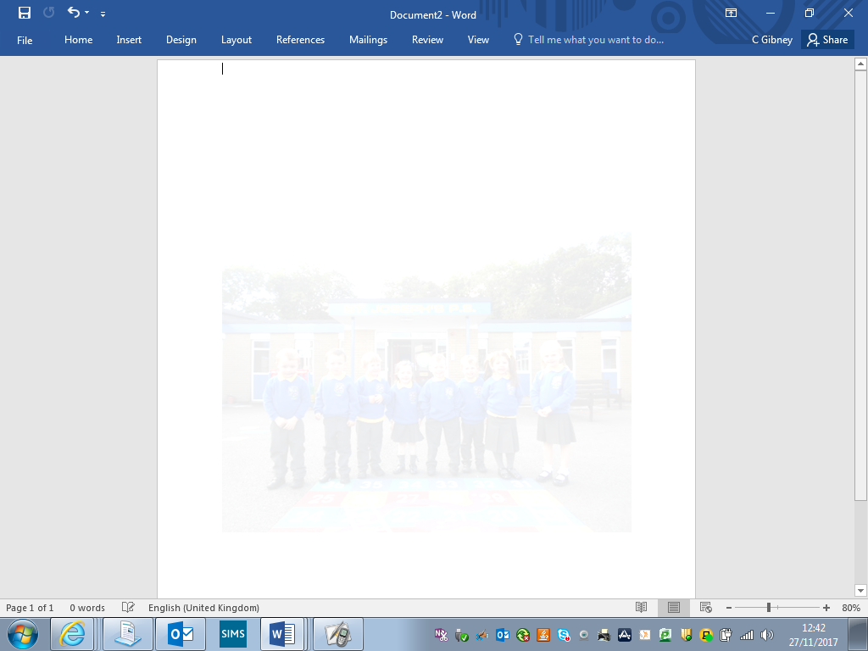

**St Joseph’s Primary School Crossgar**

**OPEN DAY**

**Tuesday 6th December at 1:30pm**

**Come and see our school in action.**

**Meet our dedicated staff and some of our talented children.**

**We look forward to meeting you.**

**www.stjosephsps.org.uk**

**www.facebook.com/stjosephscrossgar**