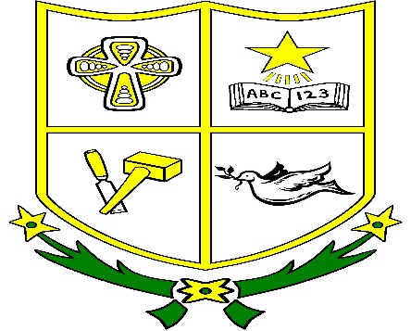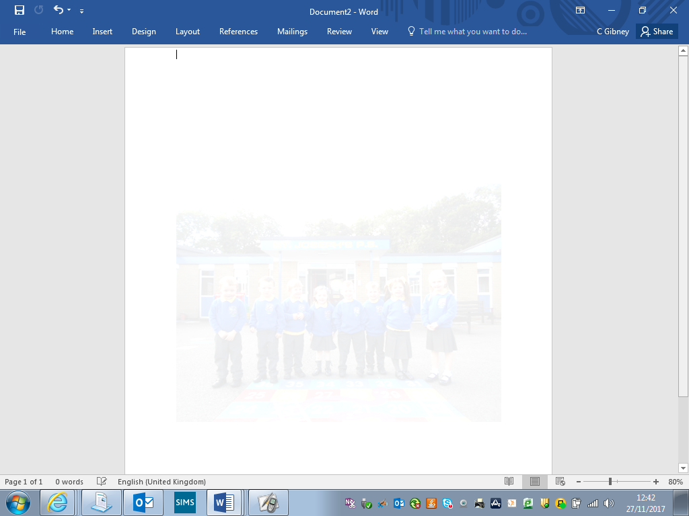

**St Joseph’s Primary School Crossgar**

**OPEN DAY**

**Wednesday 6th December 1pm**

**Come and see our school in action.**

**Meet our dedicated staff and listen to our talented choir**

**www.stjosephsps.org.uk**

**www.facebook.com/stjosephscrossgar**