Home PE Circuit

Warm ups:
- Stretch your arms to warm up arm muscles
  - Make circles forward x 5
  - Make circles backwards x 5
  - Move arms up and down 5 times
- Warm up ankles
  - Move your feet up and down x 5 each foot
  - Make circles with your feet x 5 each foot
- Warm up your neck
  - Move your head side to side 5 times each
  - Move your head forward and back 5 times

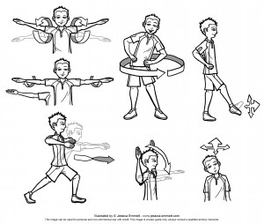

Circuits
Do each of these exercises for 30 seconds and take 30 second breaks in between each one.
- Star jumps
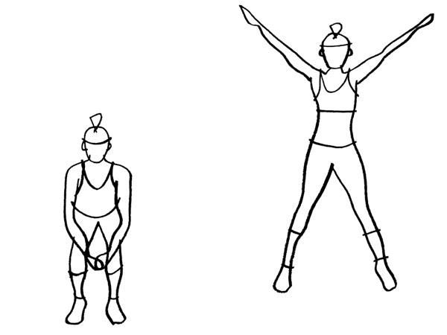
- Running on the spot
- Skipping. If you do not have a skipping rope, just jump on the spot.
- Sprint wall to wall
- Mountain climbing
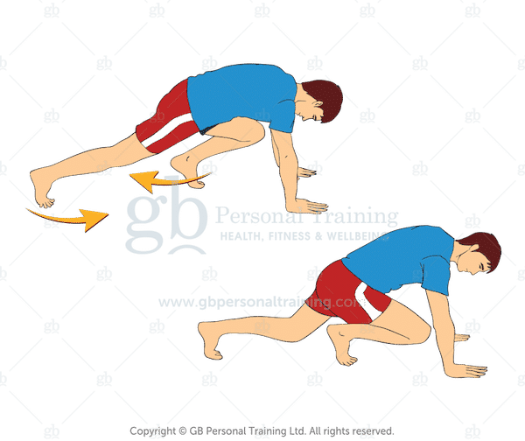
- Superman
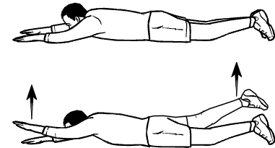

- Squats
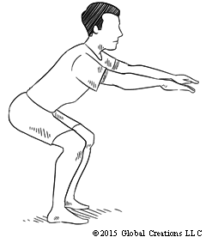

- Bicep curls - you can hold small tins or potatoes 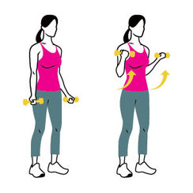
- Steps - you can do this on your first stair
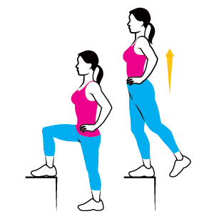

If you have more energy you can repeat the circuit.

Cooldown
- Shake all your muscles loose
- Stretch your arms and legs
- Go for a walk for a minute

