1.PRESS UPS - 5 IN TOTAL
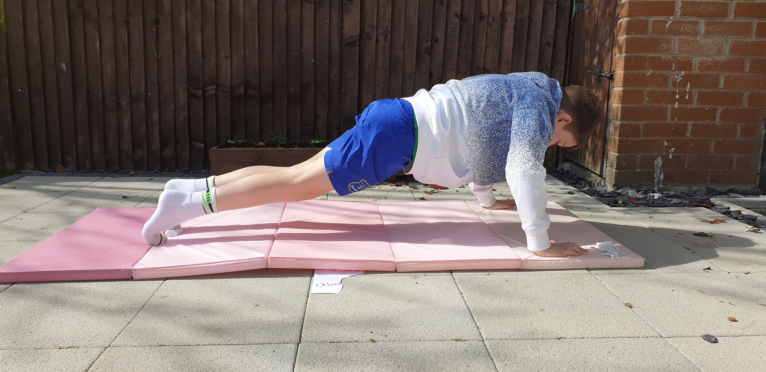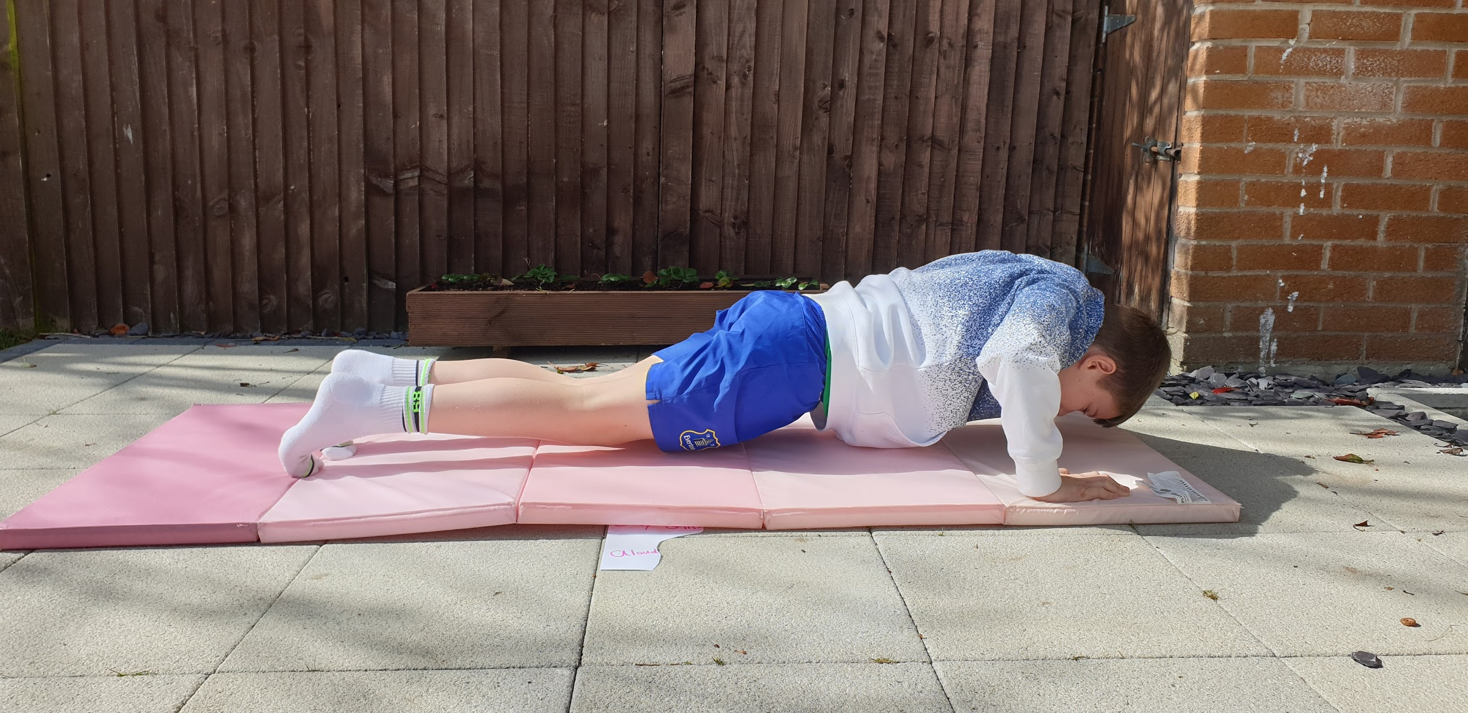

2. SIT UPS - 5, ASK AN ADULT TO HOLD YOUR FEET
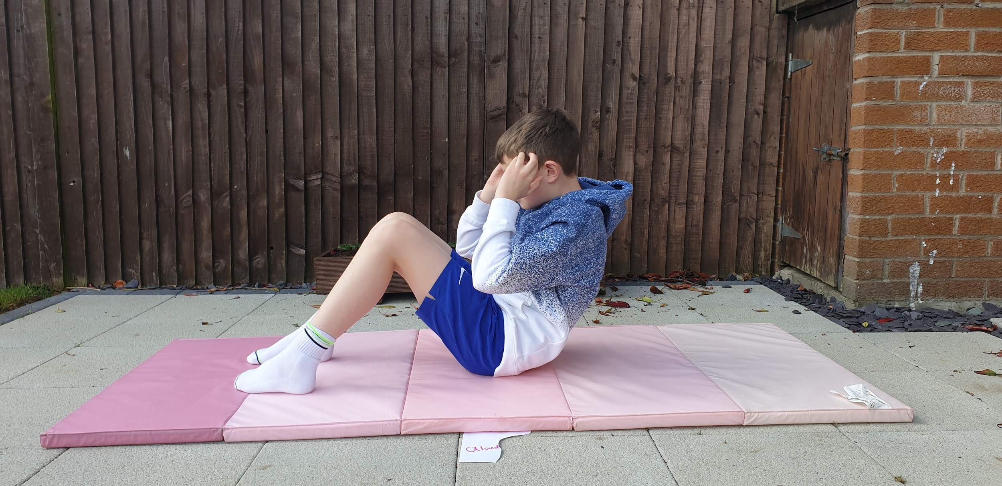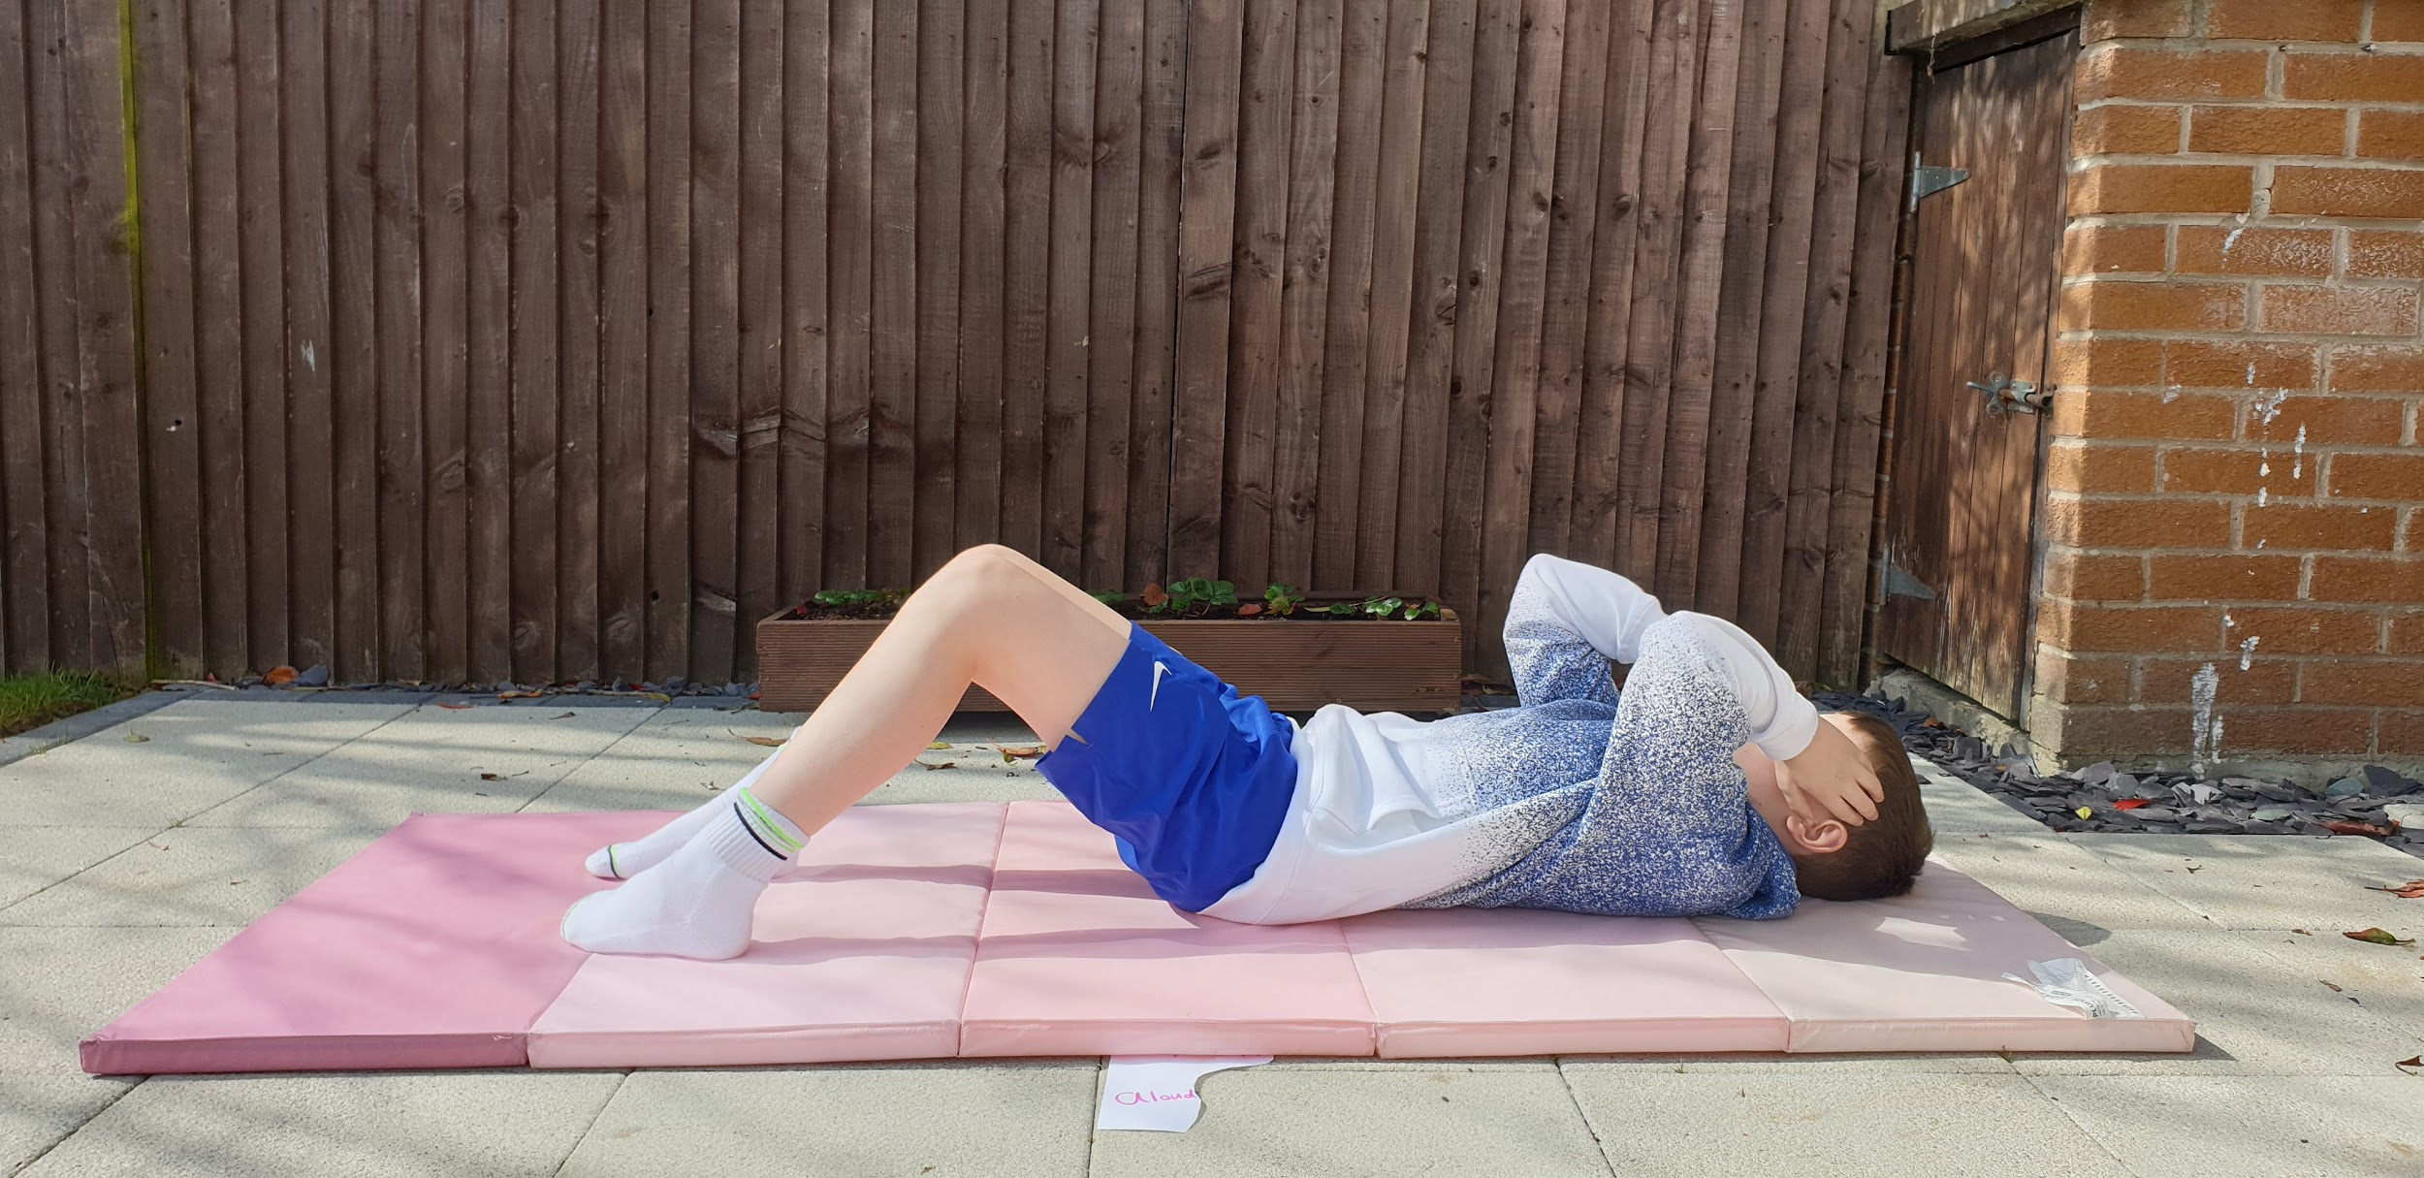

3. STAR JUMPS -10
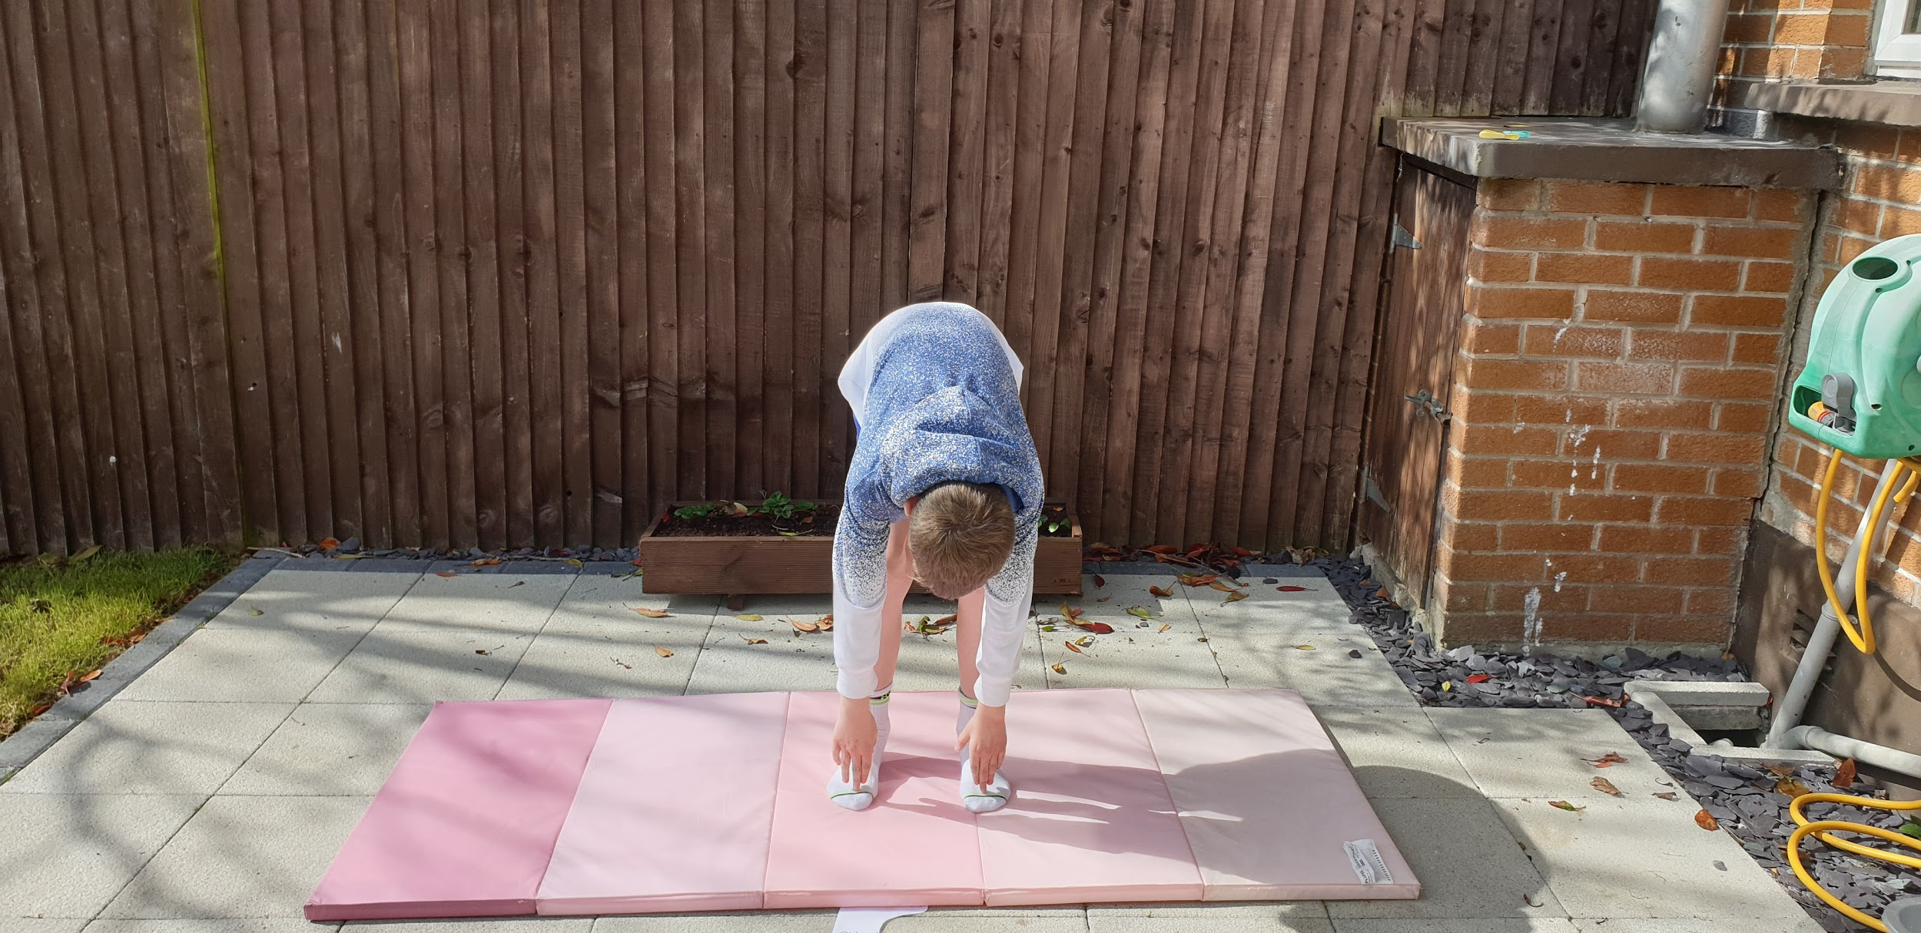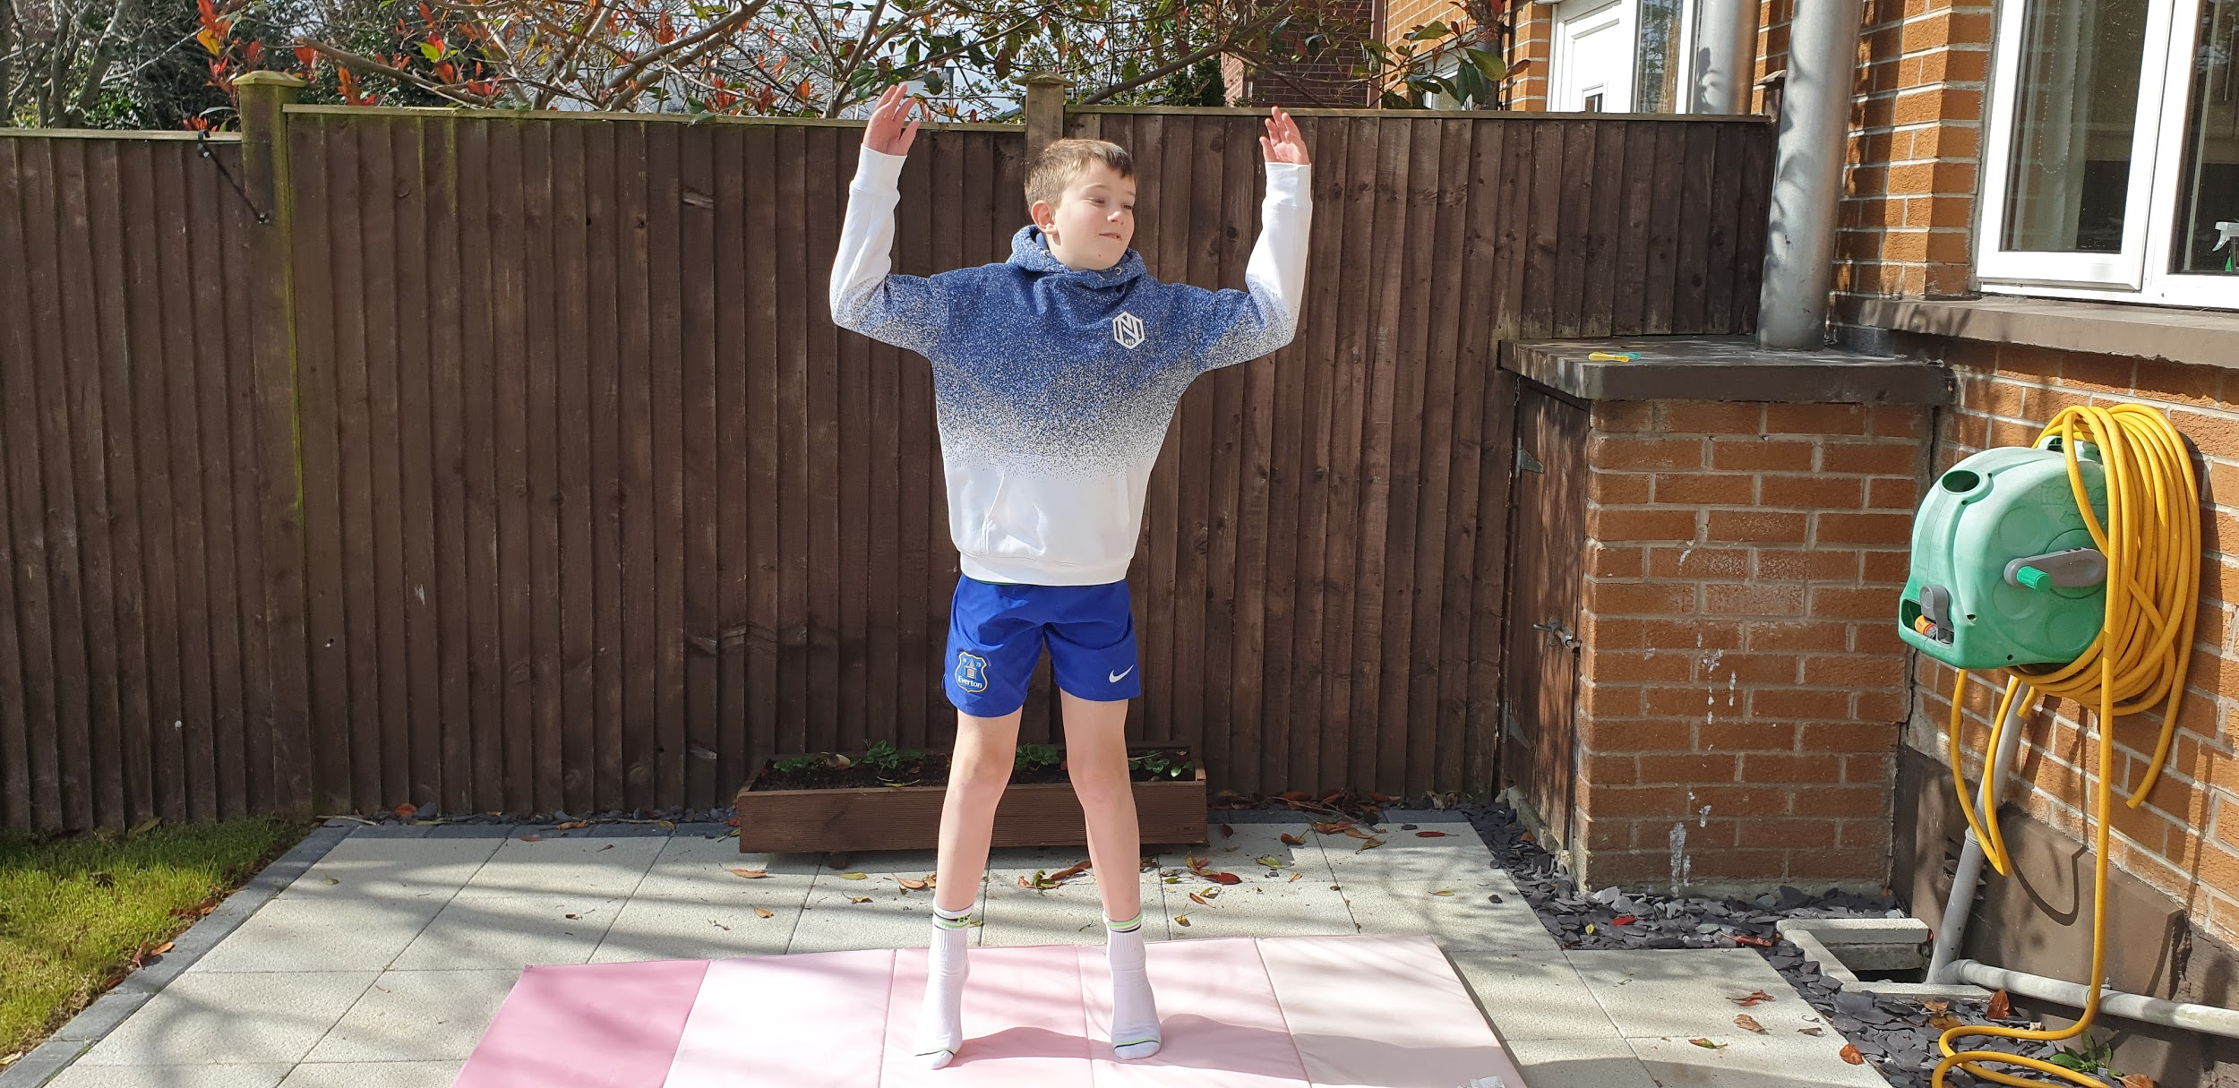

4. ARM CURLS USING TINS FROM CUPBOARD - 10
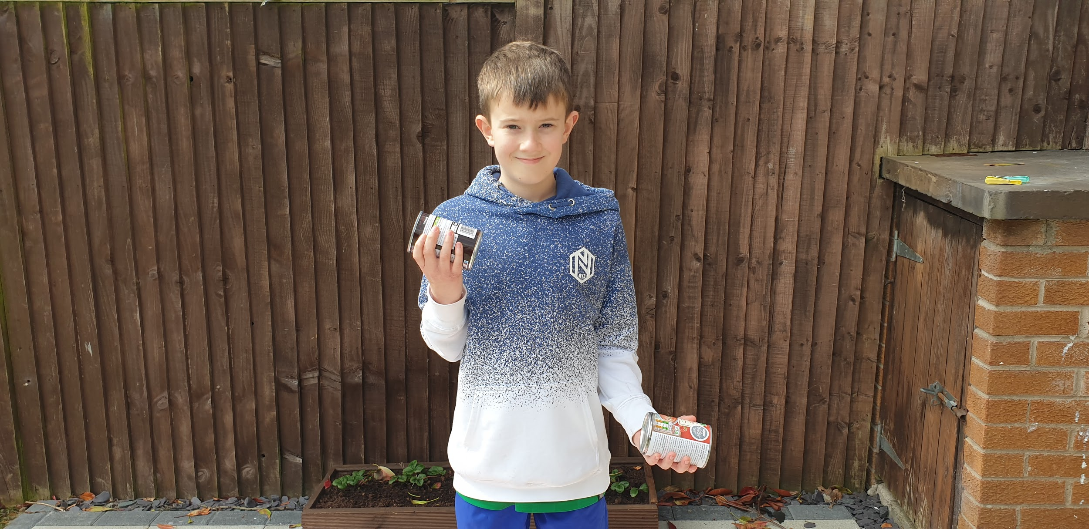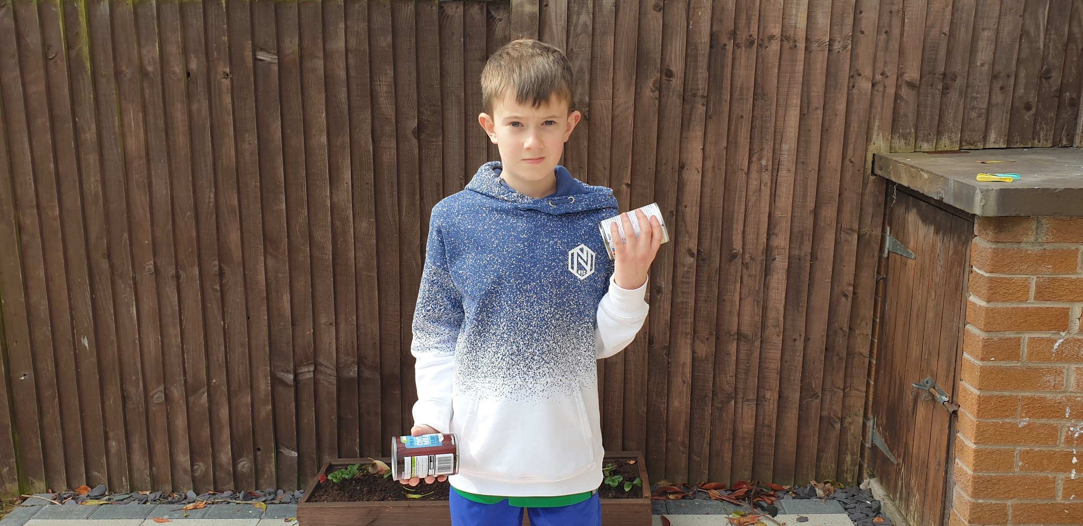

5. MOUNTAIN CLIMBERS - 10 FULLY EXTEND LEGS AND BRING KNEES UP TO CHEST
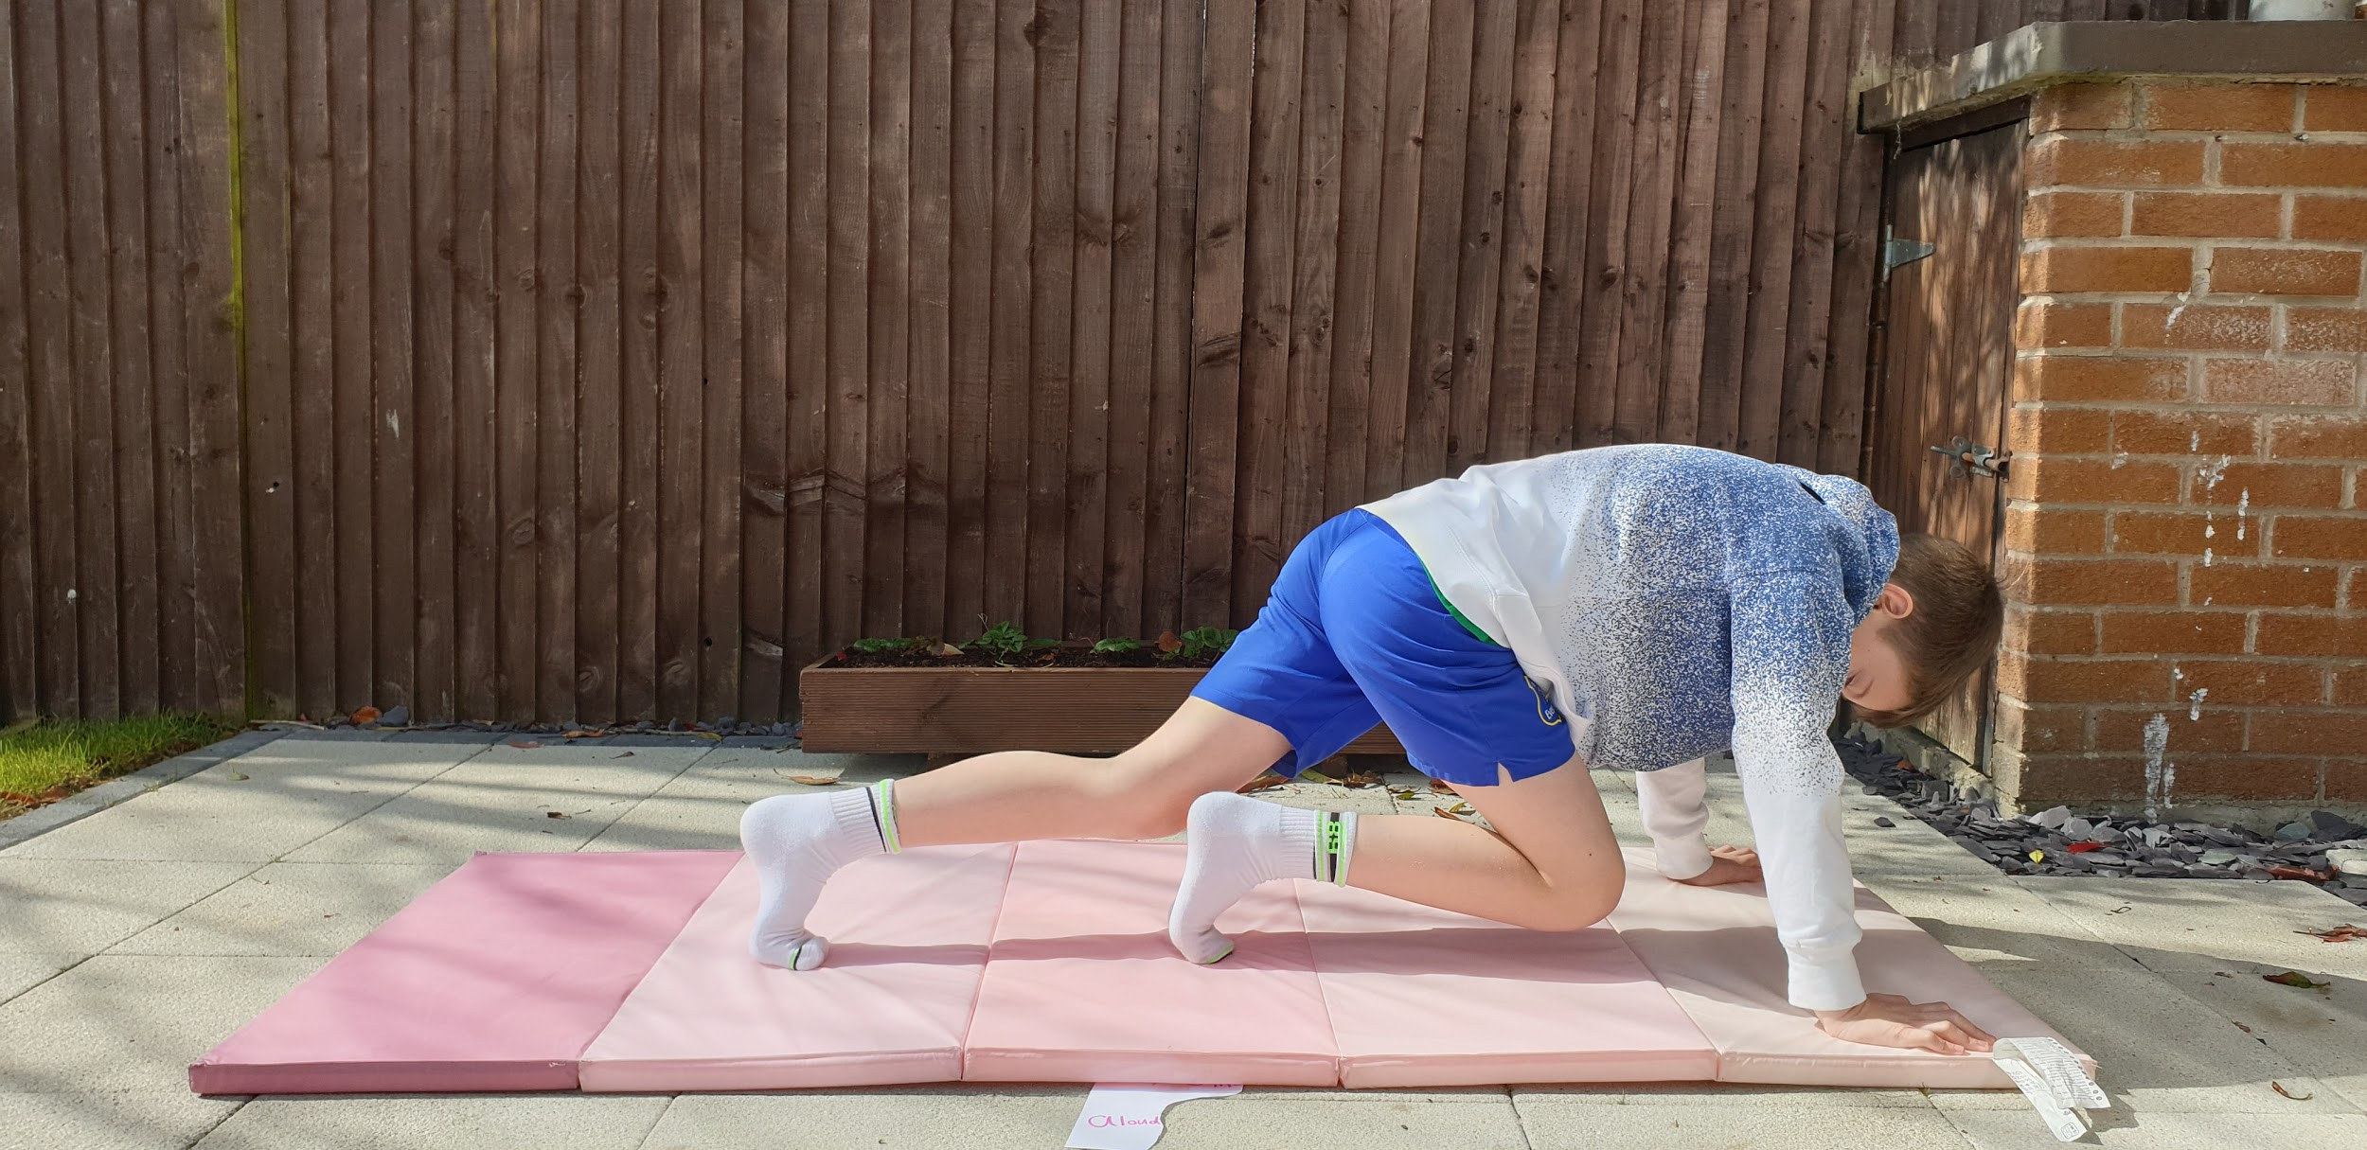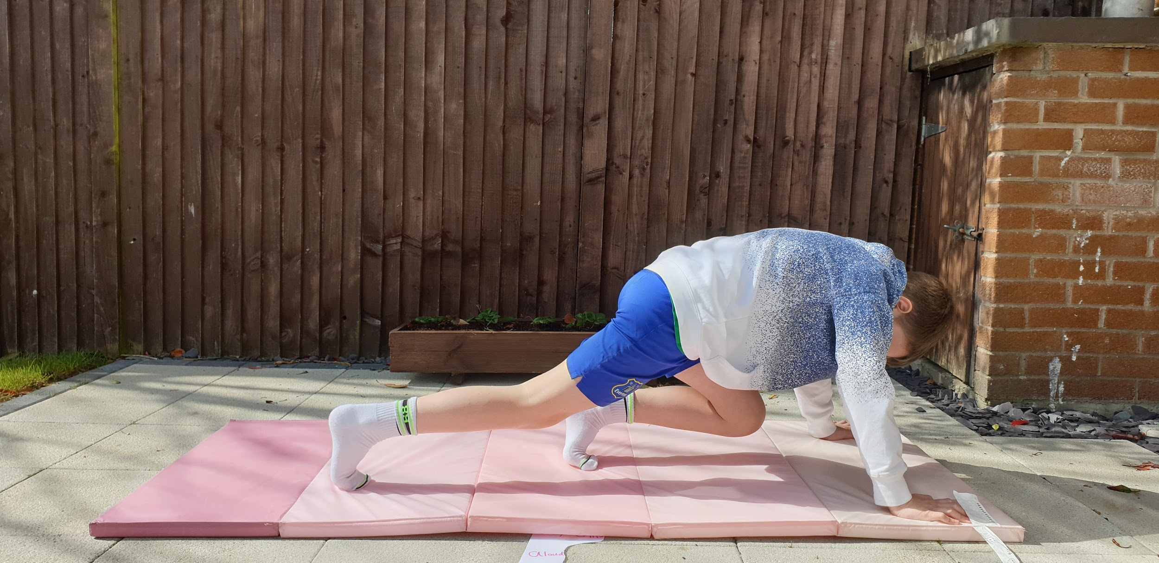

6. COVID COUGH AND STRETCH - 10 HEAD IN ELBOW ARM OUTSTRETCHED
