Home PE Circuits

- Warm up stretches for 2 minutes.

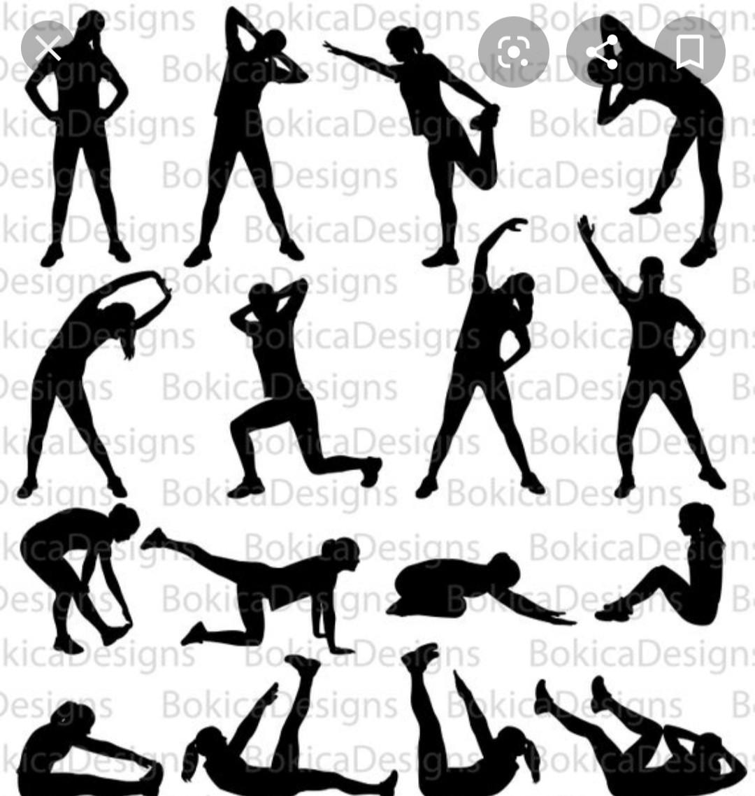

- Run on the spot for 30 seconds.

- Skip for 30 seconds.

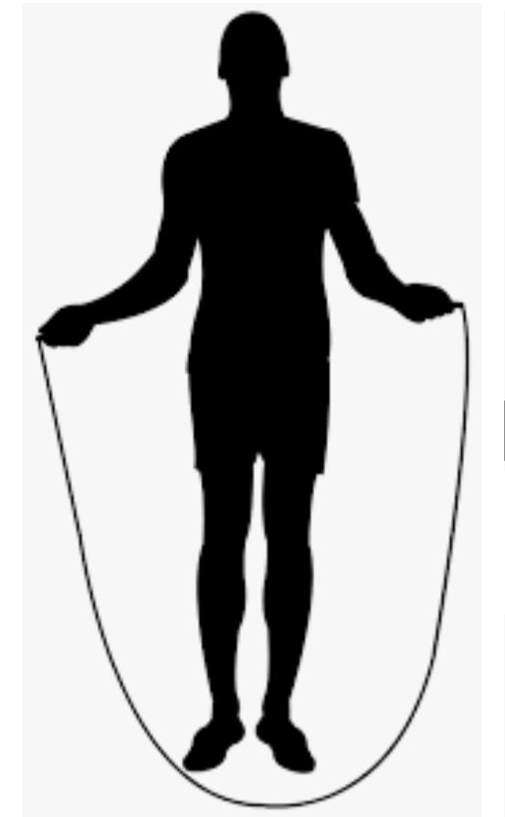

- Star jumps for 30 seconds.

- Rest for 45 seconds.

- Burpees for 45 seconds.
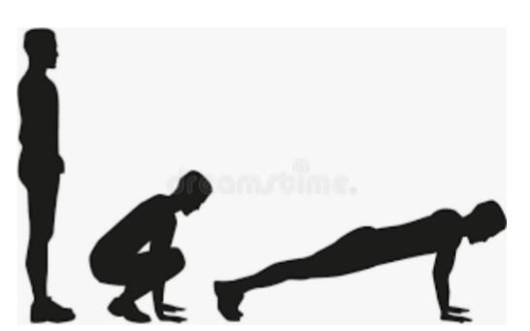

- Arm circles for 30 seconds.

- Shuttle runs for 30 seconds.
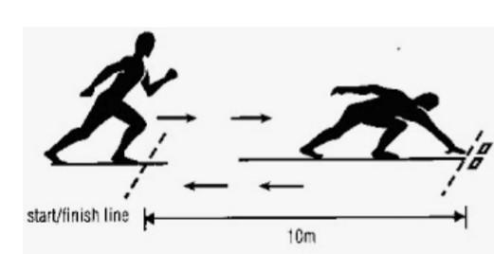

- Rest for 30 seconds.

- Repeat all of the above.

